Project Design Phase-II
Technology Stack (Architecture & Stack)
Date | 08 October 2026
Team ID
Project Name | Implement Client Script & UI Policy
Maximum Marks | 4 Marks

Technical Architecture:
The architectural diagram below shows how the user, client-side Client Scripts and UI Policies, and the server-side ServiceNow platform interact. Details are given in Table-1 and Table-2.
Example: Form behaviour control for the Incident form using Client Scripts and UI Policies
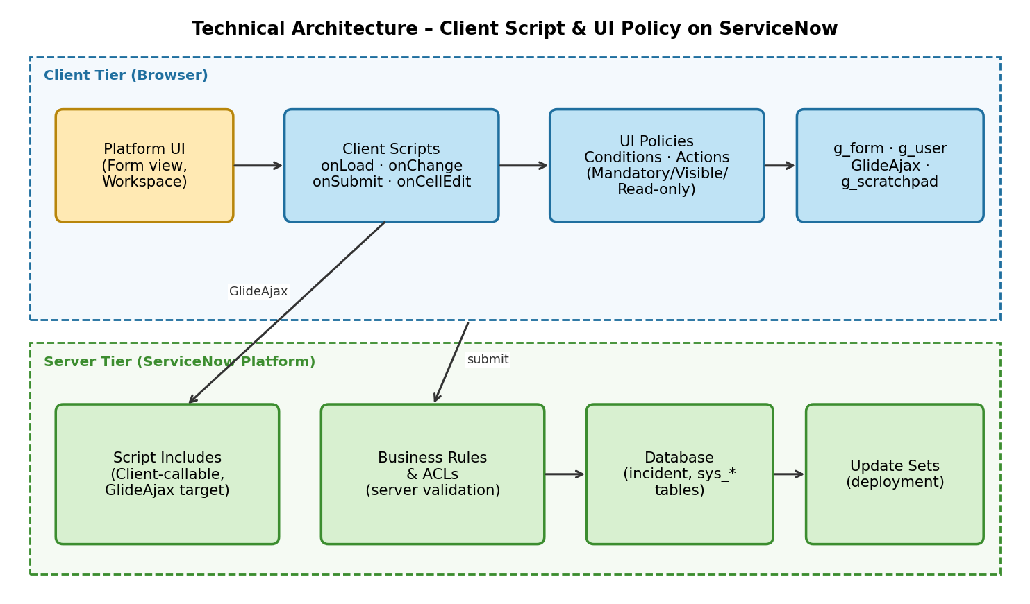
Table-1 : Components & Technologies:
S.No | Component | Description | Technology
1 | User Interface | Platform UI (Incident form) in the browser; Service Portal for end users | HTML, CSS, JavaScript, ServiceNow Form UI
2 | Application Logic-1 | Client Scripts (onLoad, onChange, onSubmit, onCellEdit) controlling form behaviour | JavaScript (g_form, g_user APIs)
3 | Application Logic-2 | UI Policies with conditions, actions and UI Policy scripts | ServiceNow UI Policy, Condition Builder
4 | Application Logic-3 | Server-side logic called from client (GlideAjax) and validation | Script Includes, Business Rules (GlideRecord)
5 | Database | Task tables and configuration tables storing records, scripts and policies | ServiceNow relational DB (incident, sys_script_client, sys_ui_policy)
6 | Cloud Database | Database hosted by the ServiceNow cloud instance | ServiceNow Cloud (managed MariaDB / Oracle-compatible)
7 | File Storage | Attachments and exported Update Set XML files | ServiceNow Attachments (sys_attachment)
8 | External API-1 | Not required for the core scenario (optional: REST Message to fetch external data) | ServiceNow REST API (optional)
9 | External API-2 | Not applicable | –
10 | Machine Learning Model | Not applicable (optional: Predictive Intelligence for category prediction) | –
11 | Infrastructure (Server / Cloud) | Application deployed on a ServiceNow Personal Developer Instance (PDI)  Local Server Configuration: Not required  Cloud Server Configuration: ServiceNow PDI hosted on ServiceNow cloud | ServiceNow Cloud, Update Sets
Table-2: Application Characteristics:
S.No | Characteristics | Description | Technology
1 | Open-Source Frameworks | JavaScript used for scripting; browser developer tools used for debugging | JavaScript, Chrome DevTools
2 | Security Implementations | Role-based access control for script editing, ACLs, server-side validation duplicates client checks, HTTPS | ACLs, Roles (admin, itil), HTTPS/TLS, OWASP guidelines
3 | Scalable Architecture | Logic is split into client and server tiers; reusable Script Includes; UI Policies preferred over scripts | 3-tier ServiceNow architecture, Script Includes
4 | Availability | Hosted on ServiceNow cloud with built-in redundancy; changes moved through Update Sets without downtime | ServiceNow Cloud (high availability data centres)
5 | Performance | Asynchronous GlideAjax, minimal onChange logic, UI Policies run without scripts where possible, client-side caching of reference values | GlideAjax, g_scratchpad, Browser cache
References:
https://developer.servicenow.com
https://docs.servicenow.com (Client Scripts, UI Policies)
https://developer.servicenow.com/dev.do#!/reference/api/latest/client/c_GlideFormAPI
https://c4model.com/

